HURDEBOURCQ Paul
TP6
R1-05 : BDD

Travaux effectués : | A retenir :
 | alter table etudiants add column hobby varchar(20) check (hobby in ('sport', 'lecture', 'cinema', 'peinture', 'sculture')) default 'sport';
 | alter table etudiants add column newcol integer
 | alter table etudiants drop column newcol;
 | alter table etudiants alter column prenometu set not null;
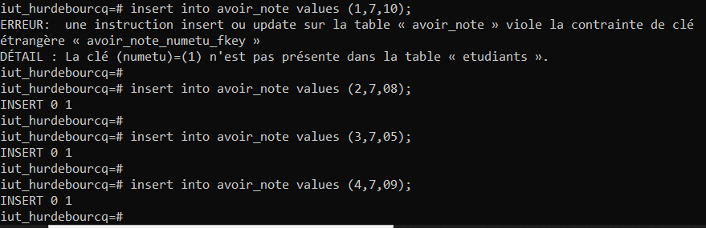 | Insert into epreuves values (7, ‘interro écrite’, 9, 1, ‘21/10/1996’, 1) ;  insert into avoir_note values (1, 7, 10) ;  insert into avoir_note values (2, 7, 08) ;  insert into avoir_note values (3, 7, 05) ;  insert into avoir_note values (4, 7, 09) ;
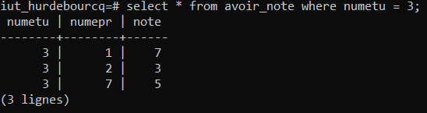 | Select * from avoir_note where numetu = 3 ;  update avoir_note set note = 7 where numetu = 3 and numepr = 7 ;  Ou bien avec cascade :  alter table avoir_note drop constraint avoir_note_numepr_fkey ;  alter table avoir_note add constraint fk_numepr foreign key (numepr) references epreuves (numepr) on delete cascade ;
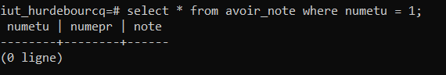 | select * from avoir_note where numetu = 1;  update avoir_note set note = note + 1 where numetu = 1 and numepr = 7 ;
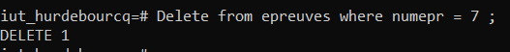 | Delete from avoir_note where numepr = 7 ;  delete from epreuves where numepr = 7 ;
 | Update avoir_note set note = note – 3 where note = ( select av.note from etudiants as et inner join avoir_notes as av on et.numetu = av.numetu inner join epreuves as ep on ep.numepr = av.numepr inner join matieres as ma on ma.nummat = ep.matepr where et.nometu = ‘marke’ and ma.nommat = ‘BD’) ;
Page 1/ 1 23/11/21

